

**STATUS REPORT ON NATIONAL YOUTH SRVICE ELDORET SUB-UNIT NOVEMBER 2021**

**PRESENTED TO**

**THE DIRECTOR GENERAL**

**PRESENTED BY:**

FR. MIKE OWUOR (VICE CHAIR SPORTS COMMITEE)

BENEDICT MATHEKA (SPORTS OFFICER)

# **INTRODUCTION**

As a matter of priority, the National Service Directorate through the Sports committee & NYS Sports officer has been bestowed with mandate to undertake sports planning and implementation. The vice chair of the sports committee and the sports officer were tasked to visit Eldoret Sub-Unit which is under Turbo Field Unit to assess the facility with a view of giving recommendations that will lead to establishment of the Sub-Unit as NYS talent development academy due to its strategic location.

# **BACK GROUND**

The National Youth Service Eldoret Sub-Unit was established in 1999 after the collapse of Nyayo Bus Corporation. The Sub-Unit is 2km from Eldoret town and it sits on 30 acres of land adjacent to Rivertex Textile & Clothing Company.

# **FINDINGS**

* The subunit is strategically located and sits on a prime land.
* Several of the buildings are temporary structures apart from one S/Men barrack which is permanent but also requires renovation.
* There is no ablution block for servicemen as the available one has been converted to a store.
* All staff quarters available in the camp are temporary Mabati/Magnifold structures that are very old and which requires urgent attention.
* The service women barrack is also temporary Mabati structure with no cemented floor.
* The camp is fenced on one side that is adjacent to the Rivertex Company leaving the rest of the camp prone to land grabbers due to lack of perimeter fence.
* The camp currently is used to host servicemen/women who are engaged on KPLC assignment and others on industrial attachment around Eldoret town and Rivertex.

# **RECOMMENDATIONS**

1. The camp infrastructure requires urgent rehabilitation and renovation to be able to support the proposed sports programmes and to achieve this objective there is need for construction of the following permanent structures:

* Service women barrack with a capacity of 100 service women and which should also be fenced off for privacy and security.
* Staff quarters comprising of six units.
* Administration Office.
* Perimeter fence to keep land grabbers at bay and secure it.
* A standard mess for both servicemen and women to give it a modern outlook.
* Ablution block.
* A permanent store.

1. A Training track/field should be established where athletics and other sports will be conducted.
2. One vehicle is needed for operations.
3. In order to achieve its intended objectives, the Sub-Unit should be upgraded to a full Unit since its far from the Mother Unit and also in a different County.
4. Two male and two female officers should be posted to the unit one of each gender being a sports officer.

# **PICTORIALS**

Pictorial 1 One of the Magnifold Staff Quarter next to servicewomen barracks

**
**

Pictorial 2: The Administrative office

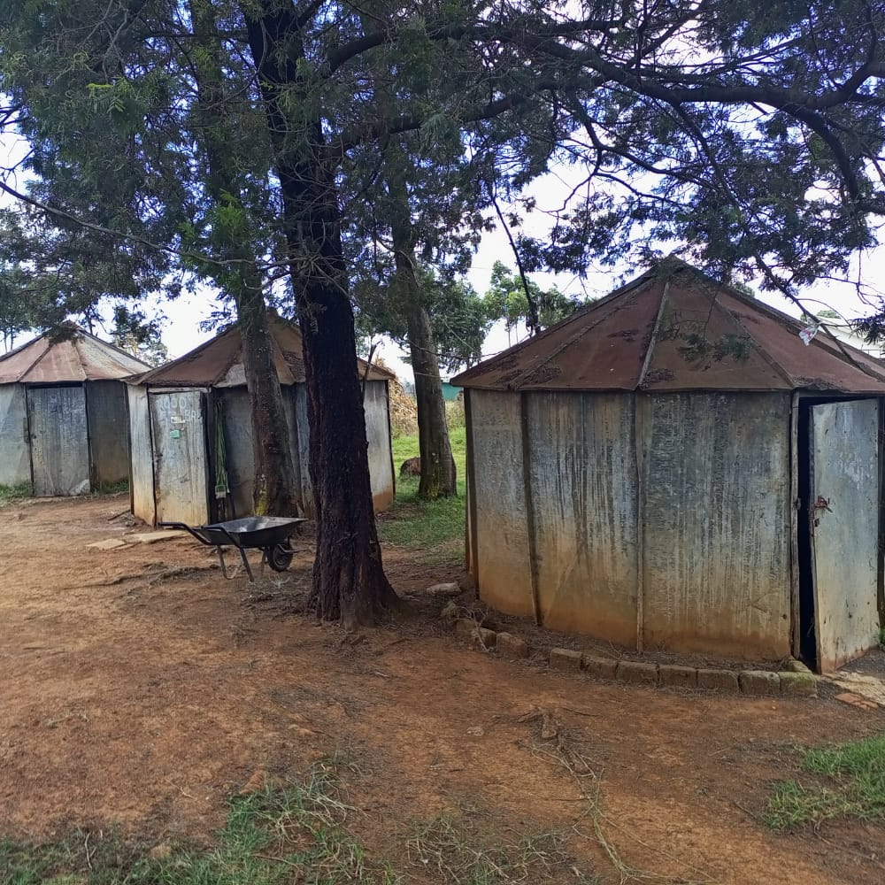

Pictorial 3: Temporary Staff Quarters

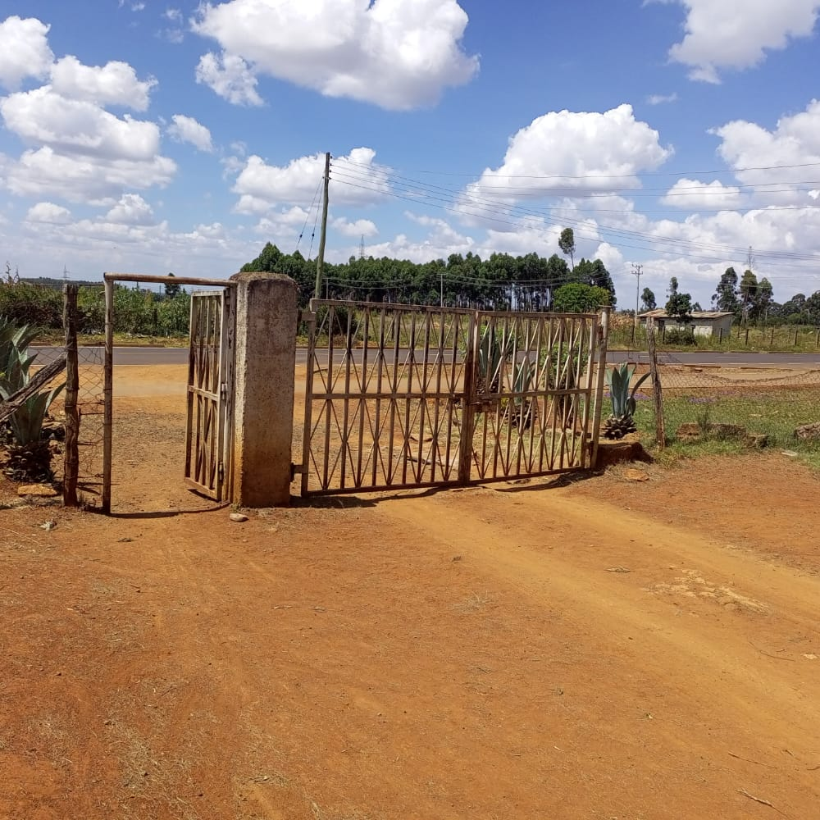

Pictorial 4: Eldoret Sub-Unit Main Entrance

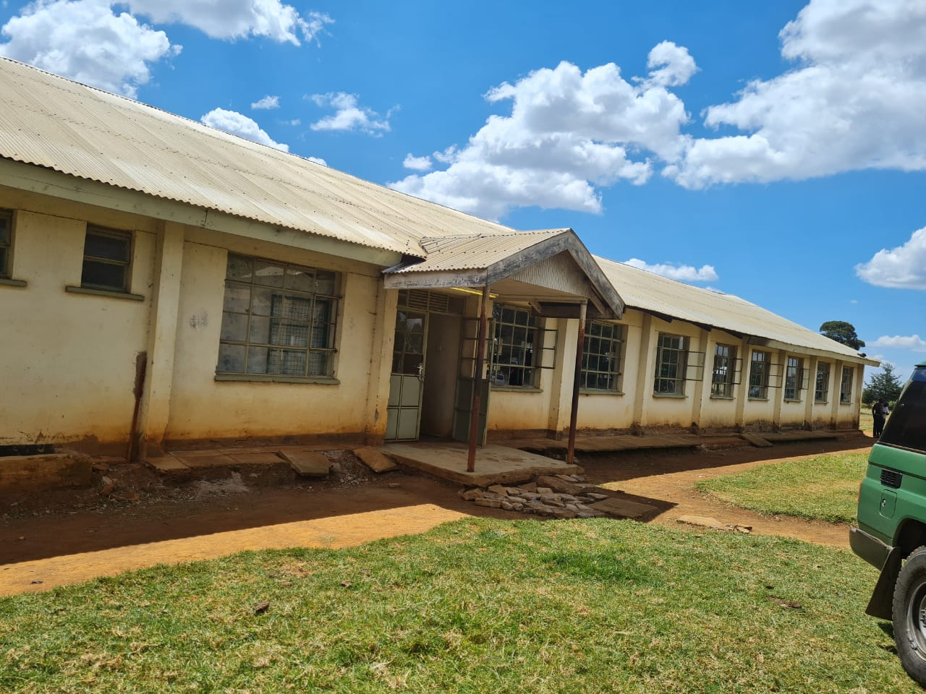

Pictorial 5: Servicemen Barrack (Requires renovation)

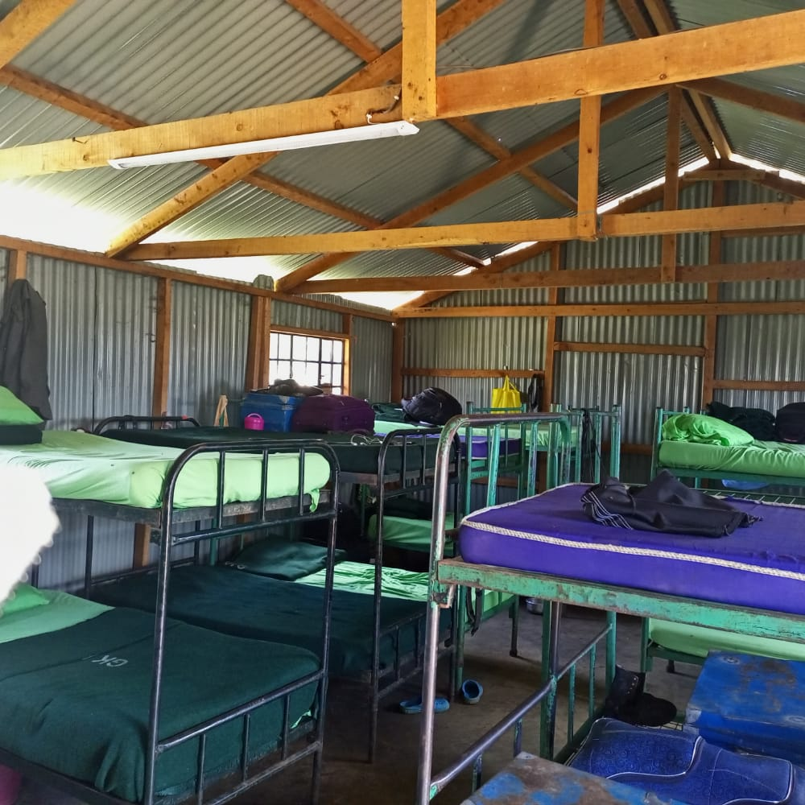

Pictorial 6: Servicewomen Barrack Interior

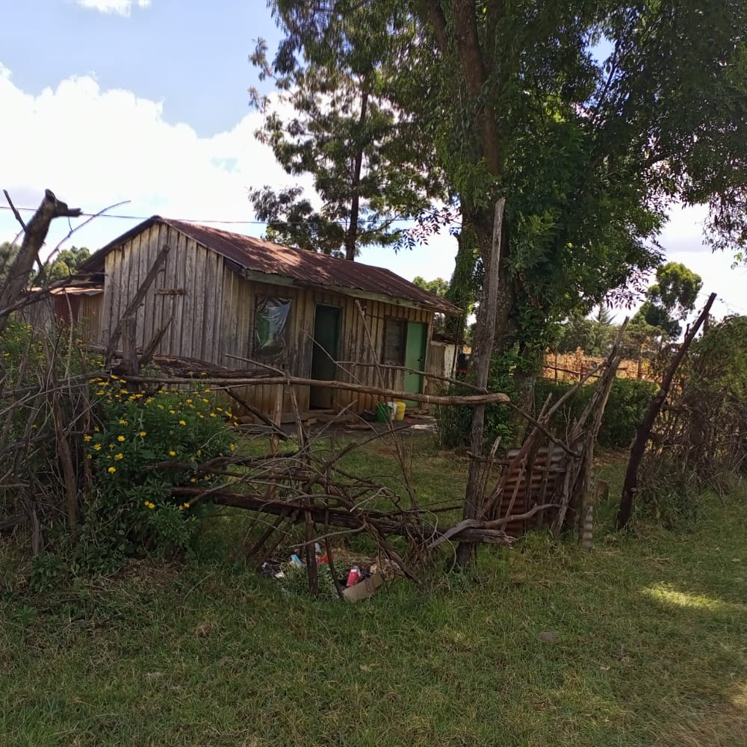

Pictorial 7: Officer In-Charge residential house (Temporary)

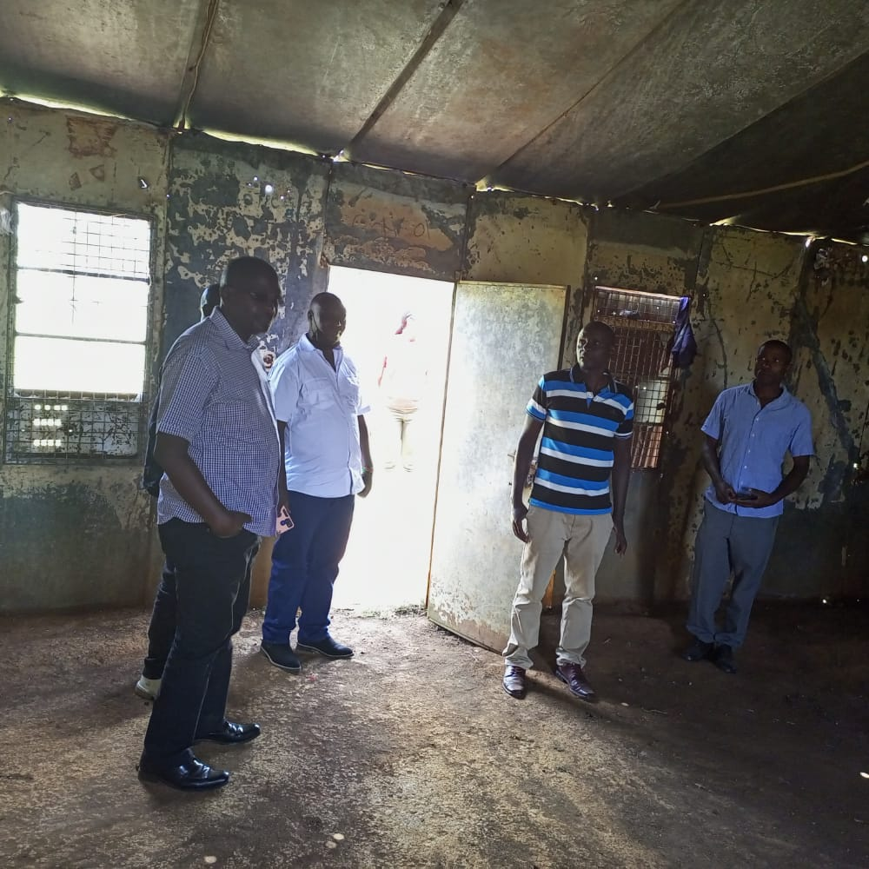

Pictorial 8: Vice Chair sports committee and other Officers from Turbo accessing the situation

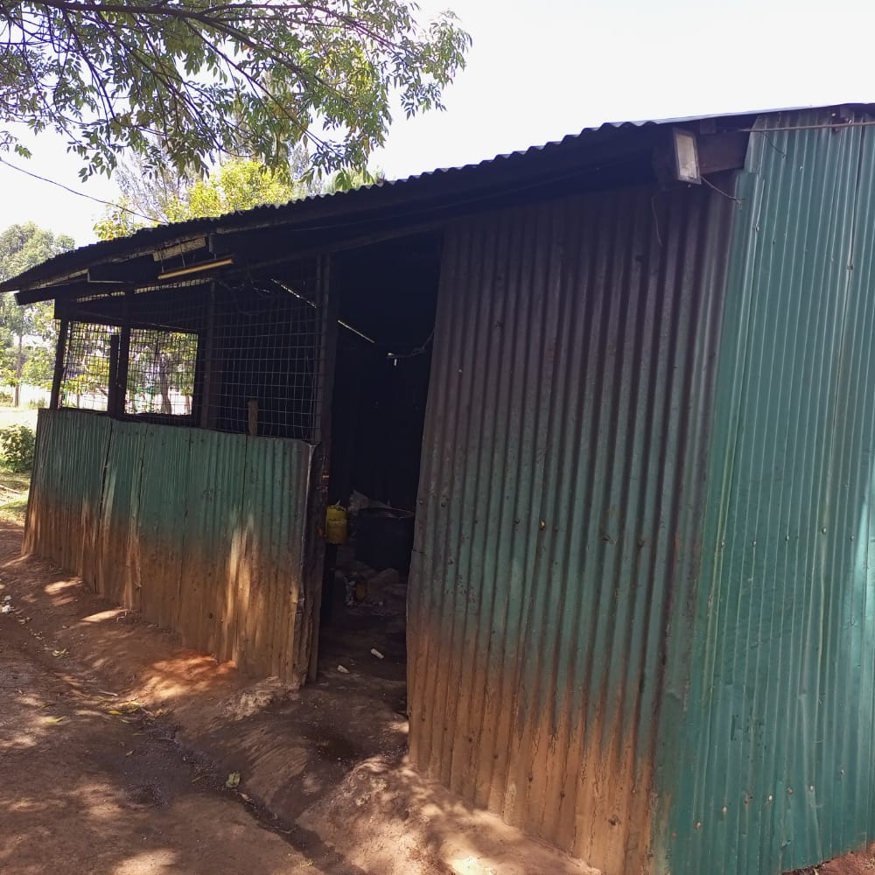

Pictorial 9: Temporary Servicemen/women Kitchen